Examine the characteristics of a biome you studied
Answer layout: Explain the term biome
Name an example studied
Outline the three or four main characteristics
Explain each characteristic with examples
A biome is a world region which is influenced by the climate. The climate is the controlling factor of the type of soil that is formed, the vegetation that grows and the animals that live there. The biome we studied is the Tropical rainforest found five degrees north and south of the equator. Our studied example is the Tropical Rainforest of the Amazon, Brazil.
The characteristics of this biome that I will discuss are Climate, Soil, Vegetation and Animals.
The Amazon rainforest is the largest of all the forests in the world. It covers almost the entire Amazon basin, mainly in Brazil, but also extending into neighbouring countries.
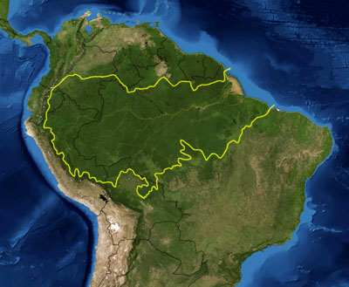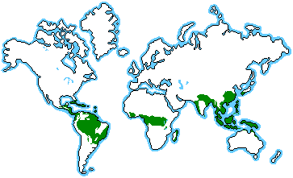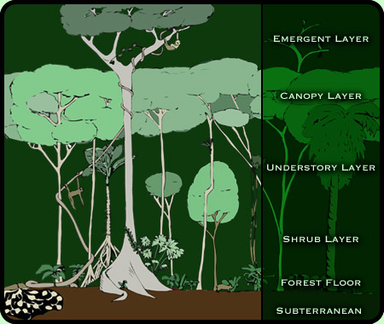
Climate
The climate of this biome is tropical. The rainforest has a warm, wet, humid, sticky climate. Temperatures range from 20 degrees to 34 degrees Celsius with an average of 27 degrees. Humidity is between 77-88%. It rains every day, at very regular intervals, starting and ending very suddenly. This is called "convectional rainfall", a term which describes how the rainfall comes about, because the sun heats the ground, which heats the air nearest the ground causing it to expand and rise, and then, when it reaches a certain height, condenses to form clouds and finally falling as rain. It is very common to have storms with this kind of convectional rainfall. This biome receives its greatest heat from the 21st of June to the 22nd of December as the sun changes position above/below the equator (Thermal Equator).
Soil
The soil type of this biome is called the latosol soil, a zonal soil that forms due to climatic conditions in certain locations around the world. This soil is low in nutrients due to the heavy rainfall regularly received which leaches much of the valuable nutrients down through the soil. Any dead organic matter is quickly decomposed by micro-organisms and heat and used by the shallow roots of the trees and vines. As a result there is a low level of nutrients and fertility with this soil type. In areas of deforestation the exposed soil is quickly washed away by the heavy rain during storms. In fact the trees of the Amazon actually protect the soils below them as the broad leaves and different layers of trees act as a type of INTERCEPTION. This is when the leaves break the fall of heavy rain and lessens the ability of the rain to strip the soil and its nutrients below.

Vegetation
The plants in the rainforest have had to adapt to this heavy rainfall order to survive. The rain causes the Amazon River to flood for a few months every year so plant life has adapted to handle this volume of water so as not to drown. There are several ways in which they have done this. Trees tend grow tall, up to 40m high, so as to break through the low cloud layer and gain the sunlight. The trees are straight and only grow branches at the top and to support this structure they grow buttress roots. The leaves have tips that curve downwards so the rain drips off.
The rainforest is actually a deciduous forest, meaning that the trees shed their leaves, although it appears to be evergreen, as the trees loose their leaves at different times. There are four clear layers of trees:
The Emergent Layer: Tallest trees from 40m to 80m in height. These trees have a shallow root system, smooth trunks and pointed leaves.
Canopy: Trees growing to 20m to 40m in height. These leafy trees are home to the majority of animal life in the forest. Strangler vines are common in this layer. These are parasitic vines that strangle and live off the trees they hug and eventually kill.
Understorey: A dark layer of vegetation with small trees and non-flowering plants. Vines called lianas use the trunks of trees to reach sunlight above this level.
Forest Floor: Less than 1% of light filters down to this level. Therefore it tends to be a dark, moist layer. Few plants grow here due to poor soil quality. Any organic matter is quickly broken down due to the heat and micro-organisms and is quickly absorbed by the roots of trees and plants.
Animals
There are millions of plant and animals that coexist in the rainforest, and yet thousand of species are still undiscovered by humans. Everything in the forest relies on everything else, creating one of the most complex ecosystems in the world. The Amazon rainforest is home to a variety of monkeys, birds, insects and ground animals. Many of these species have developed methods of adaption to survive in the conditions of the Amazon. Four of the main examples are as follows.
The jaguar requires large areas of natural habitat to survive. The third largest cat in the world, jaguars may weigh more than 300 pounds and grow to more than eight feet in length, including a two-foot tail. Most countries with jaguar populations legally protect them, but hunting and habitat loss continue to be threats to the survival of the species.
The Poison Dart Frog is one of the most noticeable but dangerous amphibians in the forest. With its striking appearance, unique features and name, the poison dart frog is one of the most interesting species in the Amazon. While many other frog species have brown or green skin, which helps camouflage themselves in the wild, the poison dart frog uses its brightly coloured skin to warn predators that it is "unfit to eat." The frog's skin also serves another protective function - it secretes a dangerous poison that can paralyze and in some cases kill predators.
The Amazon is home to almost half of South Americas parrots including the scarlet macaw. Highly intelligent, macaws mate for life and may live up to 60 years. Their splendid plumage and commercial value make them a popular species in the illegal pet trade, which has devastated populations of wild exotic birds.
The howler monkey's large vocal organ is hidden by long black hair on its throat. Using their loud, distinctive call - which can be heard up to two miles away -- howler monkeys warn other animals away from their territory. The howler monkey's diet consists mainly of fruit, much of it not yet ripe. The howler monkey lives in troops of 10 to 30 monkeys comprising both sexes.

