Examine briefly one theoretical model which attempts to explain the development of land use zones in a developed world city
I will be examining the development of Dublin City. The development of land in Dublin city can be likened to the Multiple Nuclei Model. This model was proposed in 1945 by Harris and Ullman. This theory is a mixture of Burgess and Hoyt’s development models. Those models were based on the city of Chicago.
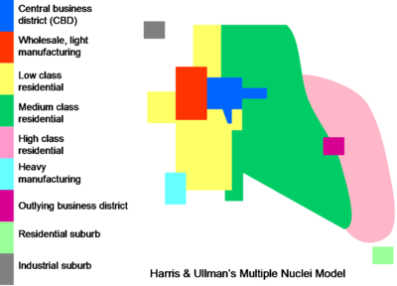
Diagram of Multiple Nuclei Model
This theory tried to show that as an urban area expands, it develops around a number of different business centres or nuclei, rather than a single Central Business District. This can be seen in Dublin city from the numerous business centres that have developed around the city. The main Central Business District of Dublin City lies in the area surrounding O’Connell Street, Grafton Street and Henry Street. Smaller areas, like Blanchardstown and Dundrum have become smaller business districts or mini CBDs. These centres attract growth and become the focus for development projects. Hence there are known as independent growth centres of Dublin.
This theory model shows that certain activites attract each other as in factories located near industrial estates. However other activites can repel land development such as housing located far away from industry. Industrial zones are usually found near residential areas with low income residents. This is usually because low income families cannot afford to live in places with higher property value. The location of land use in this model reflects the economic needs. An example of this in Dublin is the older industrial zone located near Dublin Port. This was located near the ports for easier trading. Usually high income housing develops nearer scenic routes. This can be seen from Dun Laoghaire and Malahide which are located in seaside scenic areas.
A feature of this theory are residential suburbs. This can be seen in Dublin by the residential suburb of Bray. Residential suburbs grow around major cities especially because of high property values nearer the central business district. Workers in Dublin usually live further from work and commute into the city centre. The development of transport links connecting these suburbs to the CDB is vital. Dublin has developed transport links connecting residential suburbs like Blanchardstown and Bray. These include Dart lines, the M50, N3, M1 and N11

