Question
Examine briefly one theoretical model which attempts to explain the development of land use zones in a developed world city (30 marks)
By Nadine O’ Brien

Concentric Zone Theory

This theory was proposed by Burgess in 1925. He proposed that cities grow outwards from the city centre in a series of rings. The further from the first ring, which is the CBD the higher income you earned. Each ring represents a class in society. It shows it as a class conscious society. The further from the CBD, the better the quality of housing, but the longer the commuting time.
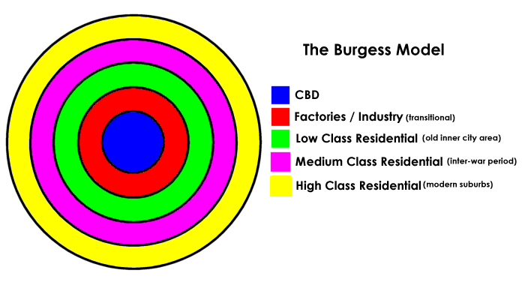
- A-CBD
- B-Zone of Transition
- C-Residential (Lower Class)
- D-Residential (Middle Class)
- E-Residential (Upper Class)

There are many assumptions regarding the Concentric Zone Theory. Burgess assumed that the older buildings were in the city centre and that newer buildings were at the edge of the city. He assumed that as the years progressed, people would build outer towards the suburbs and many would be moving to these areas.
The zones identified are:
- The center was the CBD
- The transition zone of mixed residential and commercial uses or the Zone of Transition
- Working class residential homes (inner suburbs), in later decades called inner city or Zone of independent working men's home
- Better quality middle-class homes (Outer Suburbs) or Zone of better Housing
- Commuters zone

The Concentric Zone Theory also assumes that there is a lack of transport infrastructure and there is also a strong economic and ethnic segregation. According to Burgess, he proposed that low income groups lack transport and live close to the city centre. He also proposed that cities develop on a flat plain with equal access to transport.
There are many problems associated with this theory. The fact that this theory was proposed in 1925, makes it old and doesn’t consider car ownership. In the model, the landscape is not considered, only the settlement patterns. The impact that transport and industry could have on land use is not considered. One other problem is that the model is not fully clear and the zones are never as clear-cut.

The development of land use on Dublin using the Concentric Zone Theory

The central business district is considered to extend to incorporate the area from The Point to corner of O'Connell St and Talbot St. This is where big banks, office buildings, department stores are. The buildings are usually multi-storey buildings.
Since the 1960s many people born in the city centre have moved to the new growing subarbs such as Ballymun, Tallaght and Clondalkin.
However, Tallaght as developed as a new town:
- It was chosen as a new town in the 1960s
- It has developed into an important residential, commercial and industrial area.
- It now has many facilities such as hospitals, shopping centres, libraries, Tallaght IT and many industrial estates.
- Tallaght is continuously growing and will soon become and city in its own right.

